**LINUX FOR DEVOPS**

1. **To check who are we** [ who_am_i ]
2. **To be a root user =** [sudo su ]
3. **To create a file**

* touch file1
* cat > file1
* echo “msg to be saved in file” file1

1. **To add more content to the file using echo**  [ echo “new message” >> file1 ]
2. **To create a number of files at a time** (touch file2 file3 file4).txt / touch file {(2..4)}.txt
3. **To add more than one file into another new file** = [ cat file1 file2 > file3 ]
4. **To delete the data in the file created by echo** [ echo > file name ]
5. **To hide a certain file** [ touch . filename ]

( Add a (.) before to the file and give []#ls we will not find that particular file)

1. **To print the message directly** [ echo “ Message we want to print” ]
2. **To check on which directory we are** [ pwd ]
3. **To check the files in the directory** [ ls ]
4. **To check all the hidden files in the directory** [ ls -al ]
5. **To check the properties and permissions of the files** [ls -l / stat ]

**(It will give access, modified and changed time of the file)**

1. **To check last time when a file was accessed** [ touch-a “filename” ]
2. **To check last time when a file was modified** [ touch-m “filename” ]
3. **To check last time when file metadata was changed** [stat “filename” ]
4. **To change directory** [ cd ]
5. **To come back one step back from the working directory** [ cd ..]
6. **To come out more than one step** [ cd ../../../ ]
7. **To come back to home from present working directory** [ cd ~ / cd home ]
8. **To check which processors are running** [ ps / top ]
9. **To kill any processor** [ kill PID no ]
10. **Disk Usage** [ df ]
11. **Space Usage** [ du ]
12. **Memory** [ free ]
13. **To remove a particular line** [ control + u ]
14. **To come out from current session** [ control + d ]
15. **To remove a particular word in a line** [ control + w ]
16. **To write / edit something in the file** [ nano / vi ]

**( For saving nano control+x => yes => enter)**

**(For saving vi Esc => : => wq)**

**:w = to save**

**:q = quit**

**:wq = to save and quit**

**:q! = force quit , no save**

**Creating a directory:-**

1. **To create a directory** [ mkdir ] => ex. mkdir dir1
2. **To create a number of directories at a time** [ mkdir dir2 dir3….. ]
3. **To go to directory 3 directly** [ cd dir1/dir2/dir3 ]
4. **To create a directory inside a another directory** [ mkdir -p dir4/dir5 ]

**Remove & Re-name:-**

1. **To remove a file** [rm file name ]
2. **To remove all the directories at once** [ rmdir dir* ]
3. **To remove a specified directory** [ rmdir directory name / rm_r directory name ]
4. **To remove the parent and child directory** [rmdir -p dir4/dir5 ]
5. **To remove a non-empty file & directory** [ rm -rf ]
6. **To remove all non-empty directories including parent & sub directory**  [ rm -rp ]
7. **To Rename/move/cut&paste =** [ mv old file name new file name ]

**41.To copy the content from one file to another =** [cp source file destination file / cat file1 > file2 ]

It will over write we will find in file2 which was in file1

**Creating User:-**

**42.To add user =** [ useradd username ]

**43. To check whether user is added or not =** { [root@ip] cat/etc/passwd (or) [root@ip] cat/etc/shadow ] }

**44.To see that particular user with the line number =** [root@ip] cat/etc/shadow grep “username” -n ]

**45.To create a group** [ groupadd “groupname” ]

**46.To check group is created or not** [ cat /etc/group ] there we can find our group.

**47.To add a single user to group =** [gpasswd -a “username” “groupname” ]

**48.To add multiple user to the group =** [gpasswd -M user1 user2 “groupname” ]

**Softlink/Short-cut & Hard link / Backup file:-**

**49.To create a softlink(short-cut) to any file** = [ ] #ln -s old file name softlink file name

Example :- ln -s file1 softfile (keep a new name to the softlink file for a short-cut)

This will help us to access the original file from thee short-cut file

**50.To check the short-cut file** = [cat softfile ]

**51.To update data in the short-cut file** = [cat >> softfile ] Insert something => enter => control +d

Now we can check the old file we will get all the content added by using short-cut / softlink file.

If we delete the main file we cannot access the softlink / shortcut file

**52.To delete the softlink file** = [ rm-rf “name of the softlink file” ]

**53.To create a hardlink / backup file to the original file** = [ ] #ln old file name hardlink file name

Example: - [ ] # ln file 2 hardfile (keep a new name to the hardlink file for a back-up)

**54.To update data in hardlink** = [ cat >> hardfile] Insert something => enter => control+d

Now we can check the old file we will get all the content added by using hardfile / backup file.

Even if we delete the main file also no problem, we can access the backup file / hardfile.

**Access Modes / Permissions:-**

**55.chmod = Used to change the access mode of the directory**

**d = directory, --- = file, l = link**

|  |  |  |
| --- | --- | --- |
| **Access Mode** | **File** | **Directory** |
| **r = read = 4** | **To display the content** | **To list the content** |
| **w = write = 2** | **To modify** | **To create / remove** |
| **x = execute = 1** | **To execute** | **To enter into directory** |

Example:- | d | rwx | r_x | r _ _| 1 | root| root| file size in bytes| date| time| dir/file name

D = directory

First set = root user

Second pair = group

Third pair = others

1 = symbolic link

1st root = It will represent the who is the owner of the file attached at end

2nd root = By default it will be root if group is created it will show the file at end belongs to which group

**56.To add permissions: [ chmod u+r,g+rx,o+w dir/file ]**

**57.To remove permissions: [ chmod u-r,g-rx,o-w dir/file ]**

**58.chmod 764 dir/file**

**7 = 4+2+1 = rwx**

**6 = 4+2 = rw**

**4 = 4 = r**

**59.To change the permission of folders in another location: [** chmod +r/+w/+x location of a folder]

**60.chown =** To change the owner of file directory.

**61. chgrp =** To change the group of file directory.

**tar, g zip, gun zip**

**62. tar** = Tar is an archiver used to combine multiple files into one.

**63. g zip =** g zip is an compression tool used to reduce size of a file.

**64. gun zip =** To unzip the file.

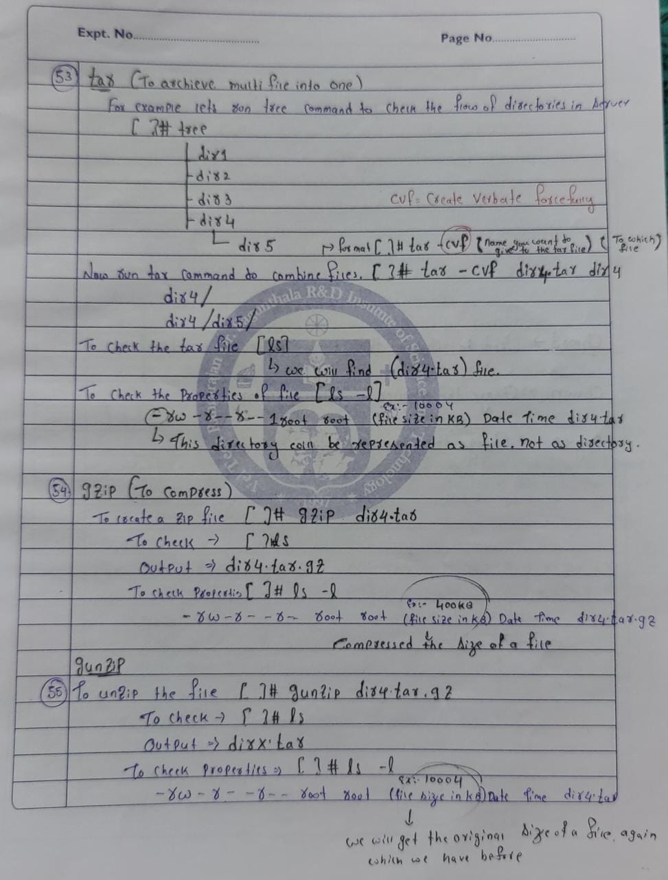

**65. wget:** [wget is the non-interact network]

To download []# wget (paste the url of the software)

To check [ls] (we will find the file that we downloaded)

To install and download file []# yum install (paste the file) -y

To check installed or not [ which (software name) ] 🡪 /bin <software name>